Q4:

Starting the nfs service and checking the status

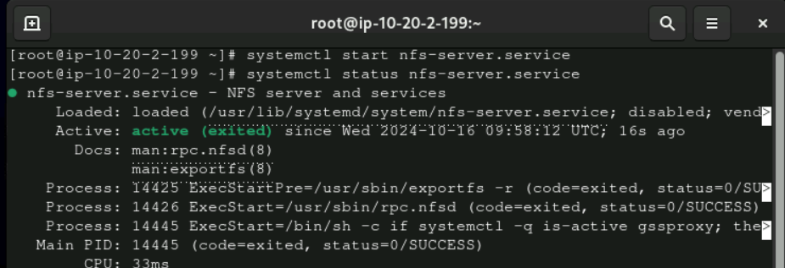

Making directory /nfsshare

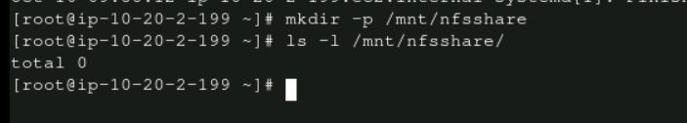

Expoting globally

Verifying things on client side

Mounting on the client side and verifying

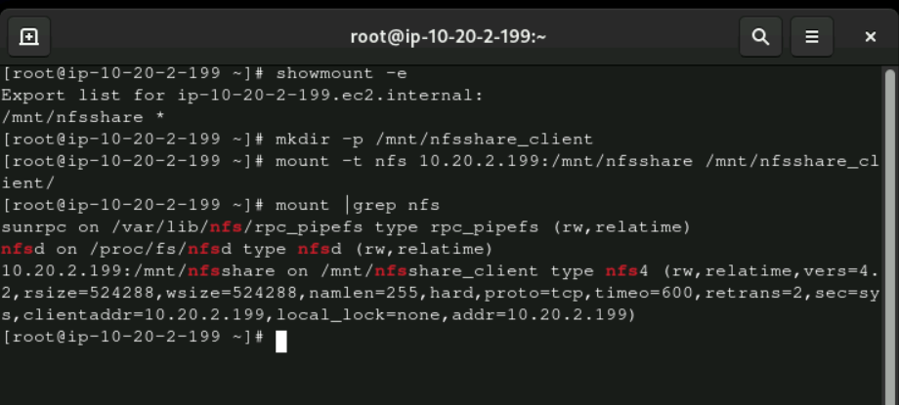

Result

